Name- Amey Waghmare

PRN- 25070123009

BRANCH- ENTC

Experiment–1

Title
Introduction to Python Programming and Installation of Jupyter Notebook Using Anaconda

Aim
To study the basics of Python programming language, understand the Python execution environment, install Python and Jupyter Notebook using Anaconda distribution, and explore various Python IDEs including Google Colab.

Objectives
- To understand Python features and applications
- To install Python and Jupyter Notebook using Anaconda
- To explore Python IDEs and environments
- To execute basic Python programs using Jupyter Notebook and Google Colab

Theory

1. Introduction to Python
Python is a high-level, interpreted, and object-oriented programming language widely used for data analysis, machine learning, automation, and scientific computing.

2. What is Anaconda?
Anaconda is a free, open-source distribution of Python and R designed for data science and machine learning.
Advantages of Anaconda:
- Comes with Python, Jupyter Notebook, Spyder, and libraries pre-installed
- Easy package and environment management
- Avoids dependency issues
- Suitable for beginners and professionals

Why python?
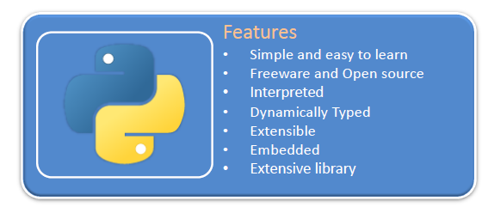
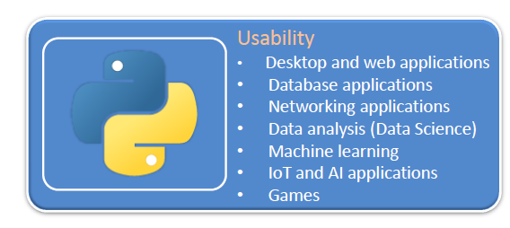

Why Jupyter NoteBook?

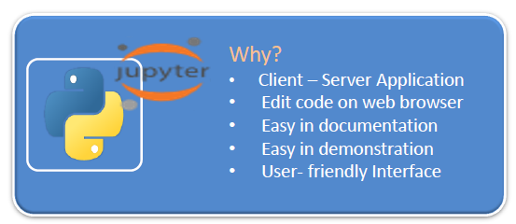

3. Installation of Anaconda and Jupyter Notebook

Step-1: Download Anaconda
- Visit the official Anaconda website: https://www.anaconda.com
- Click on Download and select Anaconda Individual Edition.
- Choose Python 3.x version suitable for your operating system.

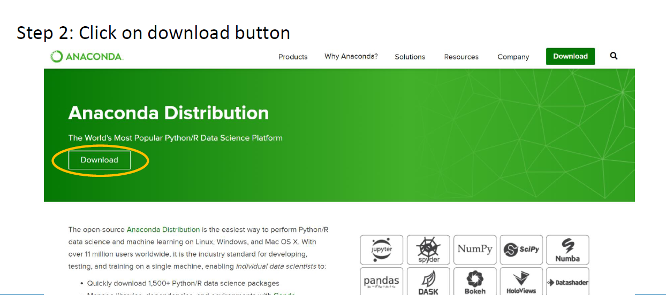

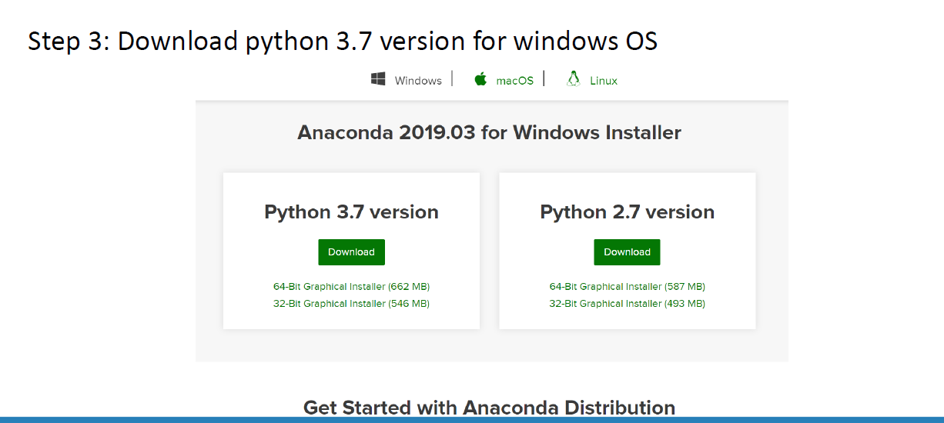

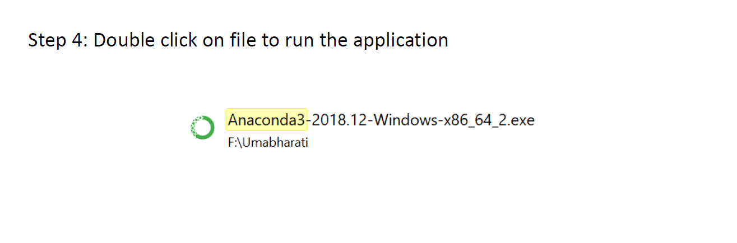

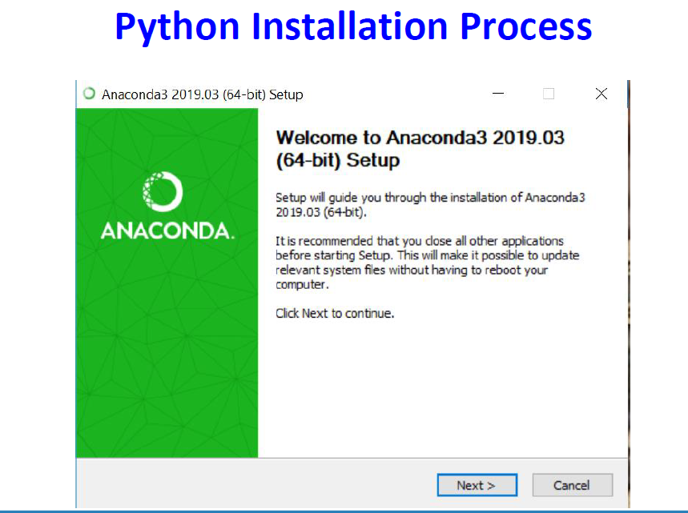

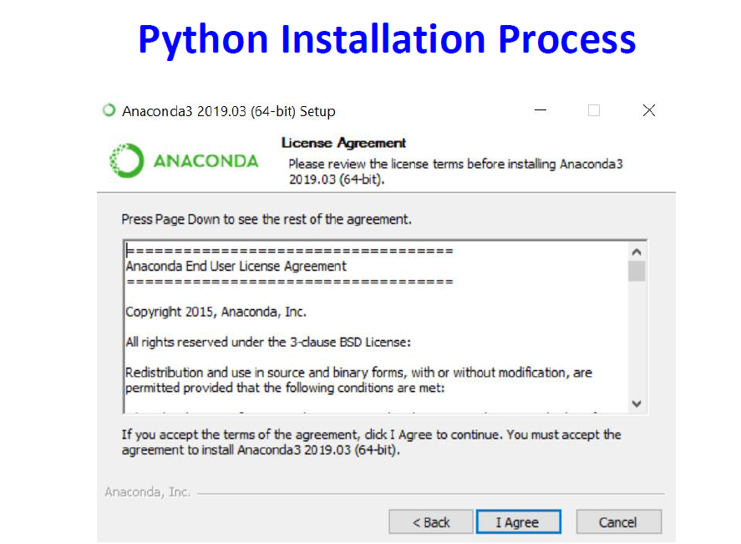

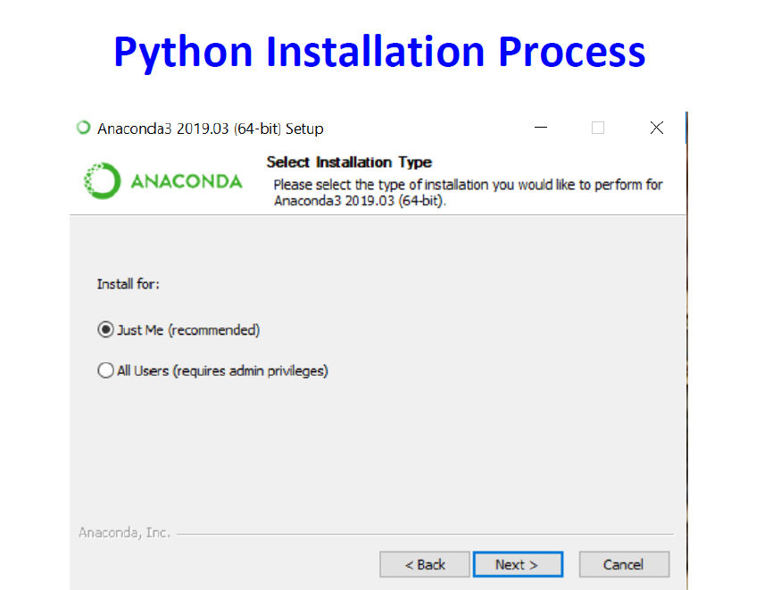

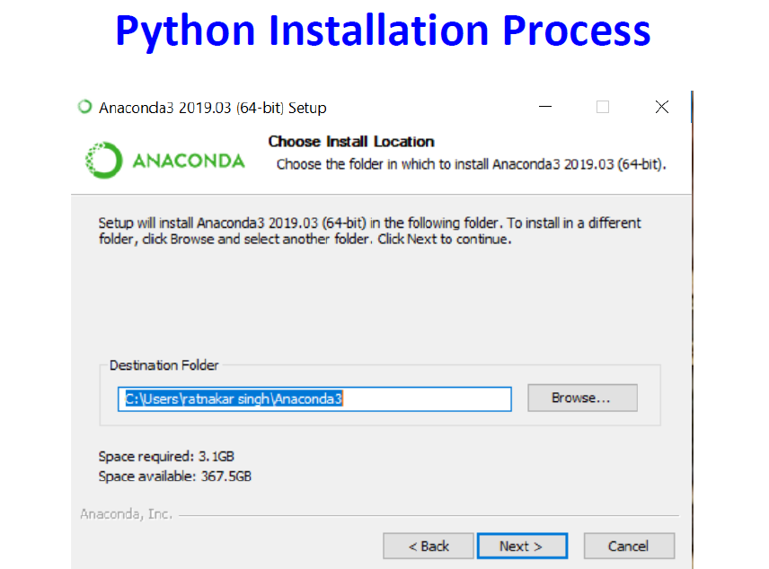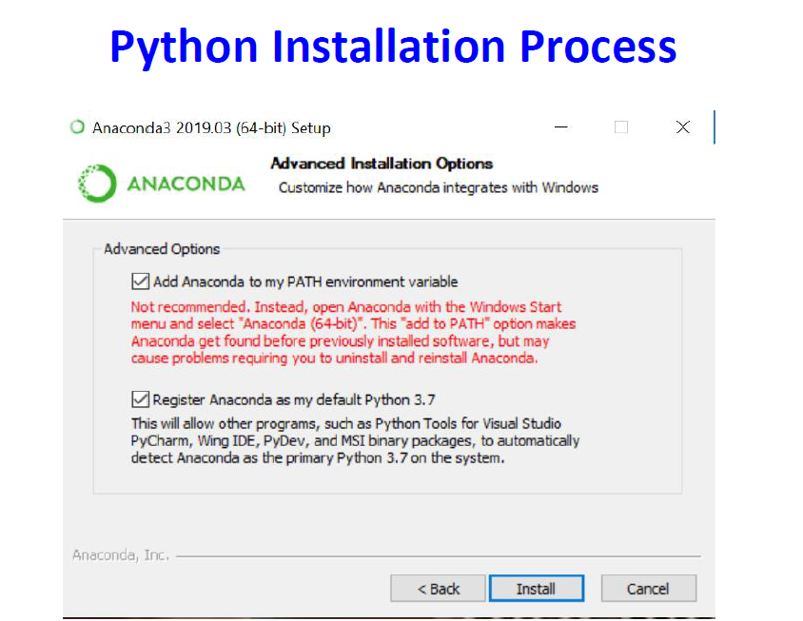

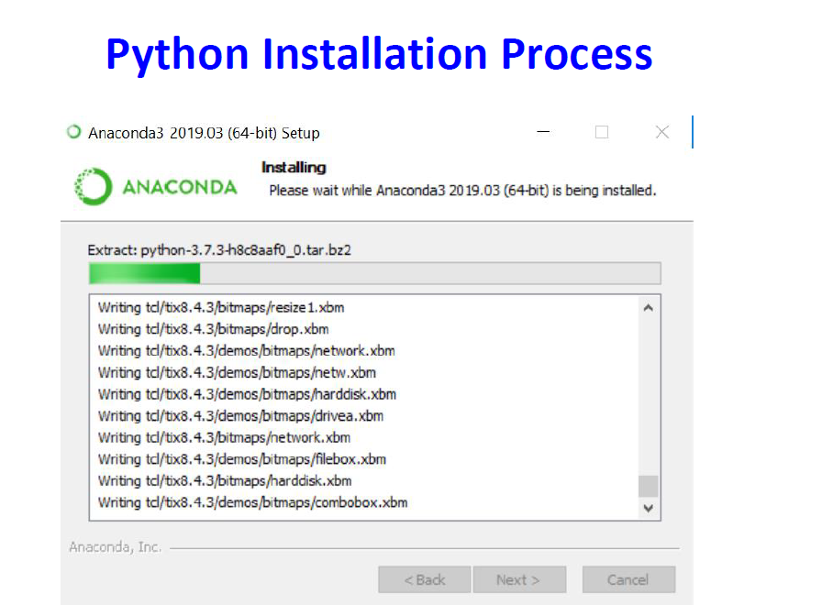

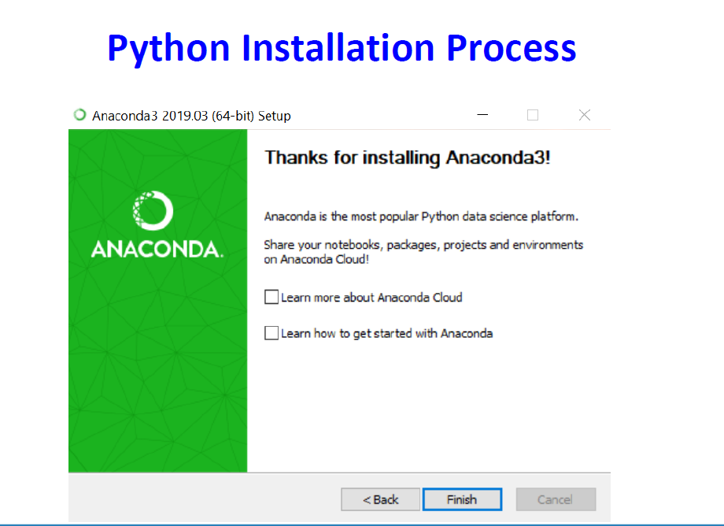

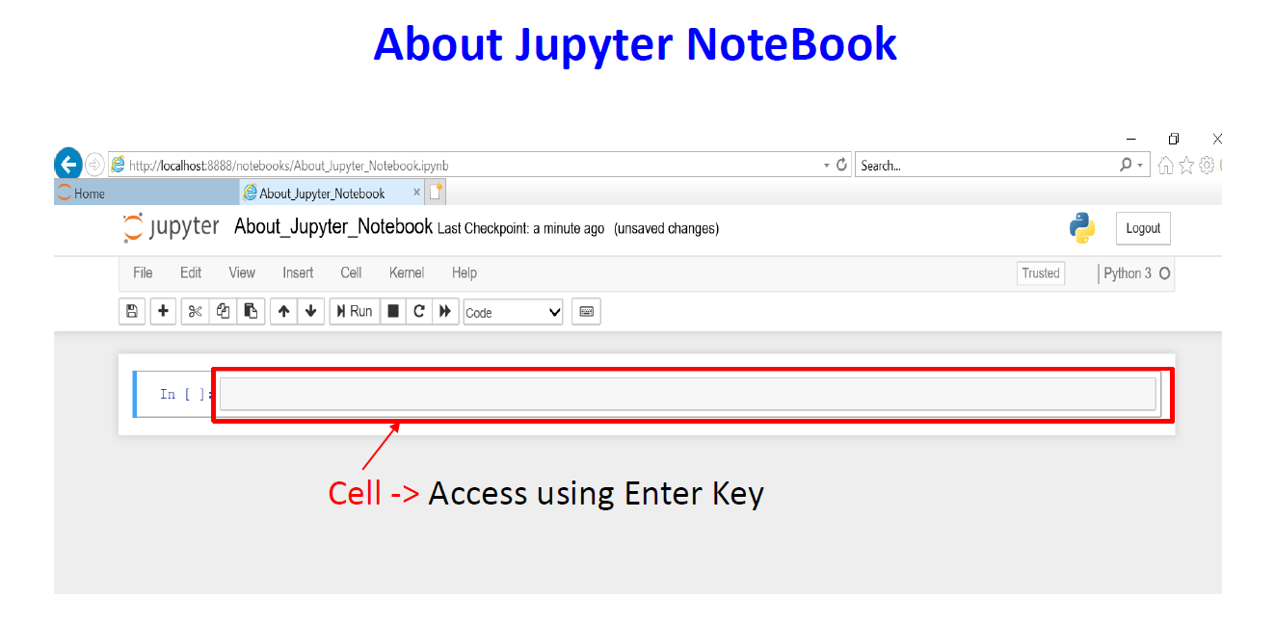

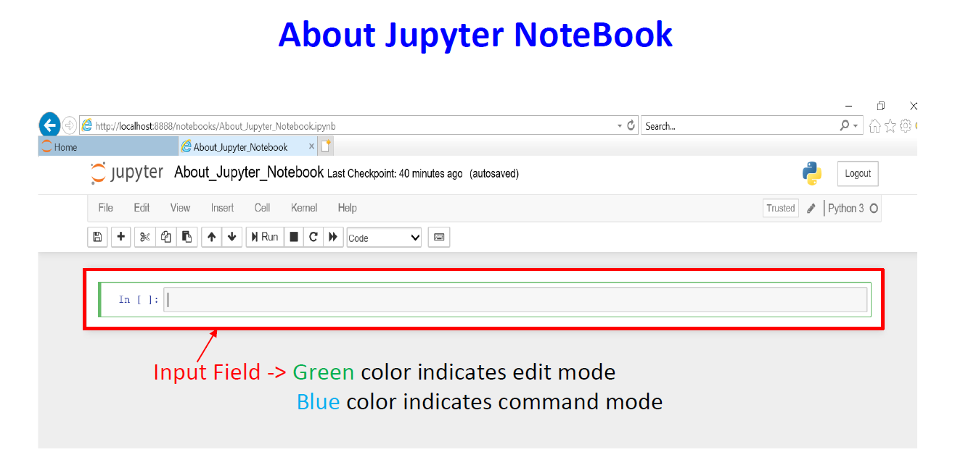

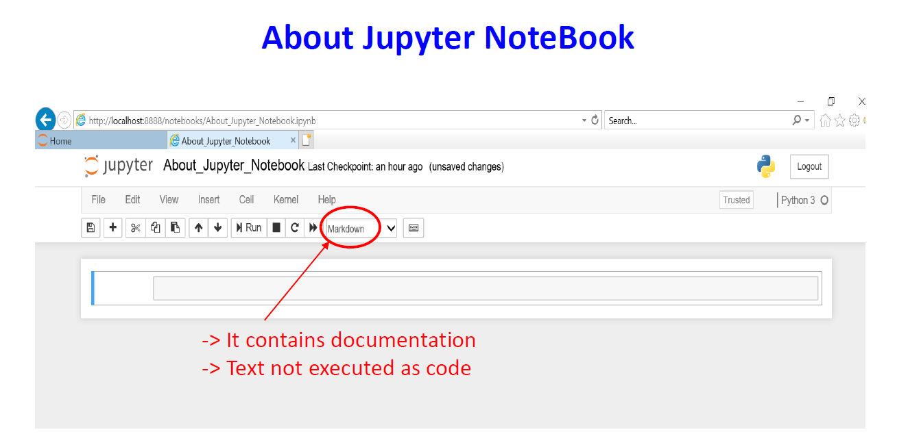

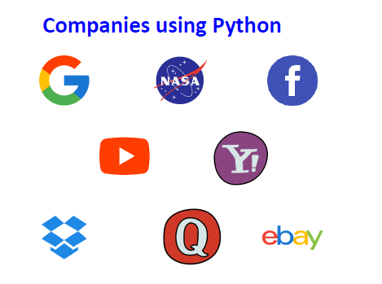

Python IDEs
IDE | Description
IDLE | Basic Python IDE
Spyder | Scientific Python IDE (Anaconda)
PyCharm | Professional Python IDE
VS Code | Lightweight code editor
Jupyter Notebook | Interactive EDA environment

Google Colab
Google Colab is a cloud-based Python environment provided by Google.
Advantages:
- No installation required
- Free GPU/TPU access
- Easy collaboration
- Runs in browser
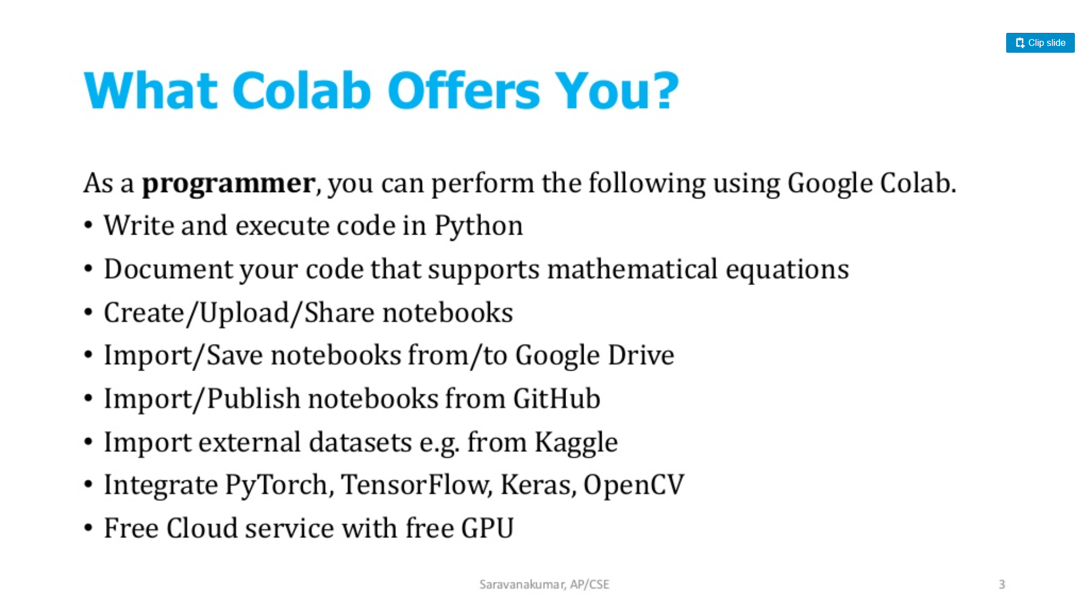
Steps to Use Google Colab:
- Visit https://colab.research.google.com
- Sign in using Google account
- Create a new Python notebook

Conclusion
Python provides a flexible and powerful programming environment. Jupyter Notebook and Google Colab simplify learning and exploratory data analysis by providing interactive execution and visualization support.

